Manual of Users

SHR+IPL+LASER

Model No.: Multi15
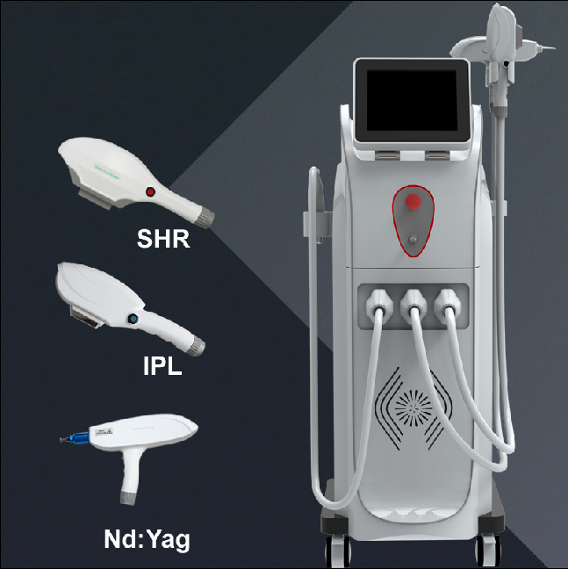

Notice

Read this manual before operation



Chapter 1 Preface

1.1 Overview

This is a Multi-functional machine combining SHR, IPL and YAG laser, together with 3 handpieces.
SHR is fast hair removal with big spot 15x50mm.
IPL has 4 filters: 430/530/590/640nm for different treatments.
YAG laser has two laser tips : 532nm and 1064nm.

1.2 Brief Introduction

Model name: Multi15
Machine type: Multi-functional machine
Size: vertical with wheels

1.3 Device Structure
This device includes: 1) main unit; 2) 3 x handpiece; 3) accessories.

1.4 Functions
SHR: fast hair removal
IPL: hair removal/skin rejuvenation/remove speckle, spider veins, acne, wrinkle
YAG laser: remove tattoo, birthmark, age spot, Nevus of Ota, Nevus

Chapter 2 Safety

2.1 Introduction

This chapter describes the proper use of this machine. Each operator must read it and understand it completely before operating the Device.

2.2 Responsibilities of the User

Notice

This device may cause thermal injury if used improperly. Medical personnel must familiarize themselves with the devices safety instructions and operational procedures prior to use.

Before each treatment, the user must check the functional performance of the device in order to rule out any risk to patients or third parties. if the device is used in conjunction with peripheral units, the User's Manuals for the peripheral units must also have been thoroughly read and understood.

2.2.1 Safety Measure

The machine is designed to prioritize the safety of the patient and medical personnel. The following are its parts of safety measures:
A. Upon switching on the system, the processor first undergoes a self-diagnostic program. The processor will then examine the system automatically and continuously during the entire treatment procedure.
B. Use the Quick Stop Switch (red button) to turn the power off in case of an emergency.
C. Remove the Key when not in use to prevent unauthorized access to the device.

2.2.2 Safety Warning

Only personnel trained by the distributor are authorized to maintain the inner workings of this device. Any manipulation to the system may cause damage to the device and will void its warranty.

2.3 Training

Notice

The SHR light, IPL light and laser light delivered by this device may cause serious injury if handled improperly. All personnel using this device must remain vigilant and utilize safety facilities

The machine requires special expertise and care in its handling and use. Only persons who have received appropriate handling training on the device, taking into consideration operating instructions, and who are familiar with its therapeutic effect and possible risks are permitted to use the laser unit.
Untrained or unqualified operating personnel are not permitted to operate the Treatments.
System under any circumstances whatsoever. offers comprehensive training courses for the the machine.
Each user must read and understand the User's Manual completely prior to starting the
operation.
Patient's safety mainly depends upon a well-trained operators and a suitable treatment room.
The attending operators must inform the patient all inherent risks with the use of this device. The success of the treatment depends largely on the user's experience and knowledge of the biophysical connections.

2.4 Explanation to Patients

The treatment process must be explained to the patient. The patient must give written-consent to the treatment.

2.5 Optical Safety

Patient must wear eyepatch. The operator and other personnel in the room should wear the protective glasses.
When use SHR or IPL, wear glasses IPL-3 (190-2000nm) CE. When use YAG laser, wear glasses 190-540&900-1700nm OD4+ CE.

2.5.1 Light Warning

The light may damage the eyes. Please observe caution at all times. Don’t look directly into the light exit during operation even if wearing the protective glasses. When not in use keep the treatment handpiece on its carriage and keep the device on standby or simmer mode.

2.5.2 Treatment Room

The treatment room should be clearly marked to prevent unnecessary access by other personal during the procedure.

2.6 Electrical and Equipment Safety

The unit uses 200V~260V 50/60Hz; 90V~130V 50/60Hz single-phase power supply. Its capability should be no less than 2000W. Use a 10A 250V more power cable.

This device connects the ground through three lines, connecting the ground well is important to the operation safety. The high voltage inside the device is very dangerous. When the device is switched off, the maximum energy remaining in the capacitor is 1000J as a residue voltage. It is not advised to open the cover. This will result in an electrical shock.

Do not open the control or rear panel even if the unit is switched off. Only authorized personnel may repair or maintain the IPL unit. Tampering with the unit will void its warranty.

2.7 Fire Prevention

The device generates thermal energy. Avoid using combustible material such as acetone or alcohol in the operative field. If alcohol based products are used to disinfect the device, ensure that the alcohol has completely evaporated prior to operation.

2.8 System Safety

The key switch is used to turn the unit on and off. Please remove the key when the unit is not in use to prevent unauthorized access. The emergency cut off switch is used to shut down the device in case of any emergency. After engaging the Quick Stop switch, turn the device off by rotating the key in a counterclockwise direction. Rotating the Quick Stop switch in the direction indicated by the white arrows will release the button.

A 20-ampere fuse is installed behind the device adjacent to the power cord. Loads in excess of 20 amperes will trip this switch.

2.9 Safe Classification of Equipment

The equipment safe classification: Electric shock protection — class Ⅰ，type BF equipment;
Corrosion preventing liquid: commonness;
Can't use this device in the environment where the combustibility, anaesthetic and the air or carbon monoxides mixture exist.
Operating mode: Consecution.

Notice

Only engineers certified by Beauty Devices are authorized to service and maintain this
device.

Chapter 3 Description

3.1 Introduction
This chapter will introduce the main parts of the system, the accessories and the process of installation & debugging.

3.2 Main unit and main parts

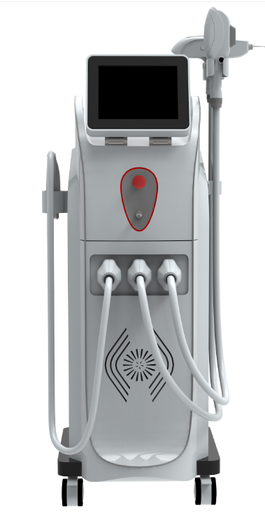

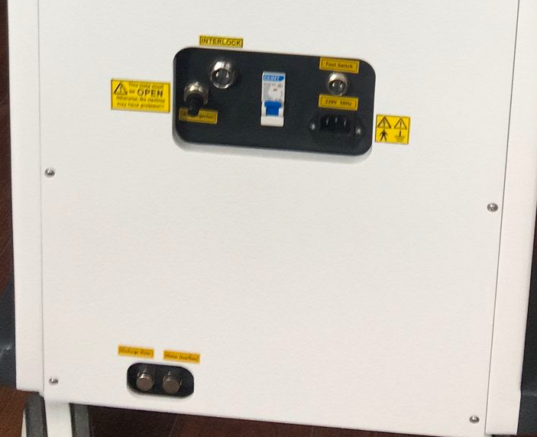
Water Injection hole
Interlock
Foot switch connector
Power socket
Air switch
Water overflow hole
Water Discharge hole
Back
3.2.1 Control Panel

Operation of this device is done through the control panel. It includes the following parts:

Key switch: Used to turn on and off the power supply. (Clockwise to turn on and counter clockwise to turn off)

Quick Stop switch: The red button found in the front panel of the device is used to immediately shut off the device's power supply in case of any emergency. Pressing this button will cut off the power supply to the whole system. Rotating the button in the direction of the arrow printed on its surface will disengage the button and will reengage the power supply. When this button is engaged, remember to turn the key switch to the off position afterwards.

Display: shows the operational settings and adjustments as well as system status is displayed on the screen.

3.2.2 The handpieces

This machines has 3 handpieces: SHR handpiece, IPL handpiece and YAg laser handpiece

Pressing on the trigger on the SHR or IPL treatment head, or press footswitch of YAG laser, discharges the flash lamp at the settings as displayed on the control panel.

The sapphire on SHR head is 15x50mm and IPL sapphire is 12x30mm. It is very important to keep the sapphire crystal clean. Make sure to clean this with a soft cloth after each treatment. A disinfectant such as alcohol can be used between treatments.

3.3 Accessories

The accessories of this device include:
SHR handpiece 1pc
IPL handpiece 1pc
YAG laser handpiece 1pc
Handpiece holder 3pc
IPL Filters 1 box = 4pc
IPL protective glasses 1 pair
YAG laser protective glasses 1 pair
Protetive eyepatch 1 pair
Funnel 1pc
Key 2pc
Power cable 1pc
Users manual 1pc
Water pipe 1pc
Foot switch 1pc

3.3.1 Handpieces

SHR handpiece uses fixed 640-950nm, only for hair removal
IPL handpiece has 4 filters for different treatments. It must use a filter for treatment.
Standard spectra | Application areas
430-1200nm | Acne therapy
530-1200 | Pigment、photo rejuvenation
590-1200nm | Vascular/spider veins
640-1200nm | Hair removal

YAG laser handpiece has two laser tips:
- 532nm tip removes red and brown pigment
- 1064nm tip removes black and blue pigment

3.3.2 Protection Glasses

Two pairs of protective glasses are provided with the device. The eye patch is to be worn by the patient and the filtered IPL-3 (190-2000nm) CE (green lens) glasses are to be worn by the operator when using SHR or IPL system; and 190-540&900-1700nm OD4+ CE (coffee lens) are to be worn by the operator when using YAG laser system. Despite wearing the protective glasses, avoid staring directly into the light exit of SHR head, or IPL head or YAG laser head during the treatment. Only personnel wearing protective glasses may be allowed to observe the treatment.

3.3.3 Light-coupling Gel

When operating SHR system or IPL system, the light-coupling gel is used to maximize the conduction of light from the flash lamp to the skin. The light-coupling gel must be clear/transparent and not colored/tinted. Colored gels absorb light therefore reducing the effectiveness of the treatment. The light-coupling gel must be chilled but not frozen. Frozen gel diffuses the light emitted by the flash lamp reducing its efficacy.
Light-coupling gels must be non-alcohol based because SHR or IPL produce considerable heat; flammable material must be kept clear of the treatment area. Please order the light-coupling gel in the local market.
The Gel is not used for YAG laser system.

3.4 System Software

The software of this device mainly has four functions:
1. Allow the doctor to choose the best characteristic parameters for the patients according to
the concrete diagnosis.
2. Control the working process of the system, in order to prevent unexpected trouble.
3. Examine the system energy .
4. Choose the treatment ranges.

3.5 The Environment Requirements

Working temperature scope: +15~+30°C
Relative humidity scope : 30%-80%
Atmospheric pressure barometric ： 86kpa – 106kpa
The store environment temperature : +5°C - +55°C
Power supply : 200V- 240V/AC,50/60Hz 20A

Chapter 4 Installation

The process of installation includes: (Performed by an authorized technician only)
1. Unpacking the device.
2. Staying the device for one day, in order to avoid destruction by high humidity during long distant transportation.
3. Assembly of its components and ensure that all connections are firmly in place.
4. Fill the water tank with distilled water or pure water.

4.1 Equipment Detailed List

The following is the detailed list of equipment of this device::
SHR handpiece 1pc
IPL handpiece 1pc
YAG laser handpiece 1pc
Handpiece holder 3pc
IPL Filters 1 box = 4pc
IPL protective glasses 1 pair
YAG laser protective glasses 1 pair
Protetive eyepatch 1 pair
Funnel 1pc
Key 2pc
Power cable 1pc
Users manual 1pc
Water pipe 1pc
Foot switch 1pc

4.2 Installation Requirements

Before unpacking the device, ensure that working environment conforms to the requirements of this section.

Before assembly of the device’s components, ensure that high humidity is cleared away by opening the packing and staying the device for one day.

4.2.1 Location Requirements

The device should be positioned in an area with adequate ventilation away from devices that produce heat (i.e. refrigerator).

4.2.2 Electrical Requirements

Before the IPL leaves the factory, it has already been marked the local rated voltage according to the customers' request.
Input electric current can't have momentary change, electric voltage or electric current peak sink.
It is recommended that this device use a dedicated power supply with its own circuit breaker.

4.2.3 Environment Requirements

Air quality: No caustic particle (such as acid) in the air, which can damage the electric wire,
the electric component and optical component surfaces. The dust in the air should be as little as
possible, or it can absorb the energy of light and be heated up. When the dust falls on the surface
of the filter, it may damage the filter. Metal particles also could damage the electric component.
Temperature: The IPL system has an optimal working temperature between 15C~30C.

Relative humidity should not be over 80%. The working power of this device is about 3000 KW.

It would be best that the machine which is installed in an air-conditioned room where the relative humidity
and temperature can be maintained at optimal levels.

4.3 Installation

1.Raise the screen slowly.
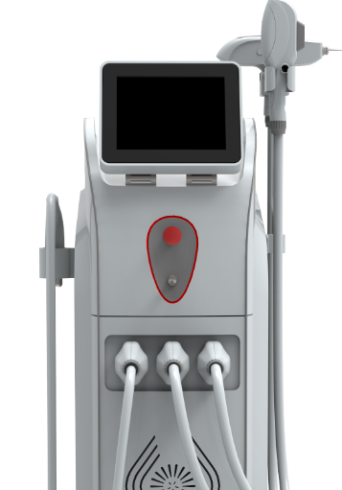

- Install handle holders and Hanging the 3 handles.

3. Install 3 handles onto the machine

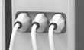
SHR
IPL
YAG

When to connect the handle onto the machine, please:
- don’t draw the handle hose too hardly, or the handle may be pull off from the holder and drop on ground leading to broken
- please push-in the two lock buttons on both side of the handle plug
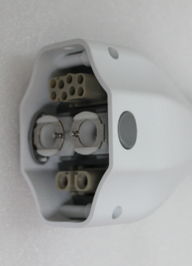
Push-in
Some strength is needed to connect the handle plug onto the handle socket. You should hear two sounds pa…pa or the two sounds happen at the same time. The lock buttons bounces. That’s means the connection is finished. Or you need to re-connect it.

4.4 Water-In

Pure water or distilled water is needed.
Before Water-In, please take down the two plugs in the Water-In and Water Overflow on the back of the machine.
The method to take down the two plugs is to 1) push in the blue outlet and 2) pull out the plug at the same time.
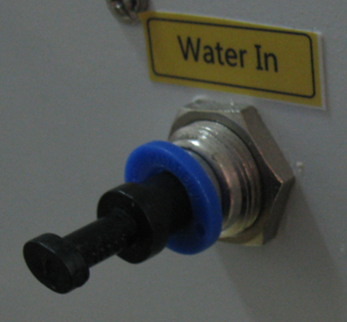
1. push in the blue outlet
2. pull out the plug
Add water:
- Open the Water Overflow and get a basin ready under the Water Overflow.
- Connect water pipe and funnel.
- Add pure water or distilled water from Water-In until water runs out from Water Overflow.
- Close the Water Overflow.

Connect Interlock
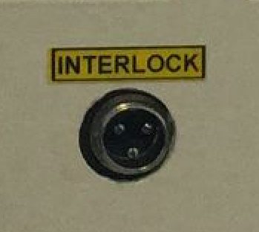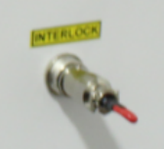

Notice

After adding water, please don’t plug the Water In hole because the water cycling system produces air during the machine work. The air must be released, or the water cycling system may get damage.

Chapter 5. Operation

5.1 Equipment operation (treatment process):

5.1.1 The requirements for operator
Apparatus for the operator should understand professional knowledge, the training of qualified medical professionals or beautician operate the machine.
5.1.2 Operation steps
1 You need switched on the power supply
2 In the emergency stop switch turned on, right turning key switch, that machine begin to work.
3 That you can see the following screen interface:
The screen displays logo as you open the general power supply switch. This logo can be changed into any other logo as customers want.
LOGO
4 Press the screen and enter Figure one as below:
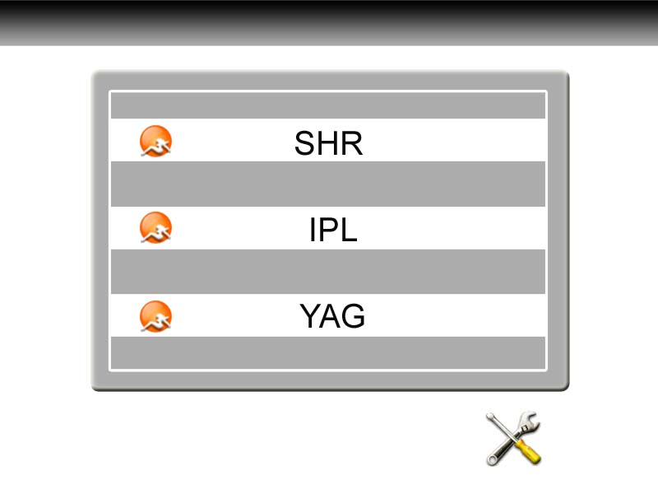
Figure one
In Figure one, it is SHR, IPL, YAG. 3 systems. Choose the right system you need. Lets start SHR firstly.

5.1.2.1 SHR Operation
Click .
Treatment interface:
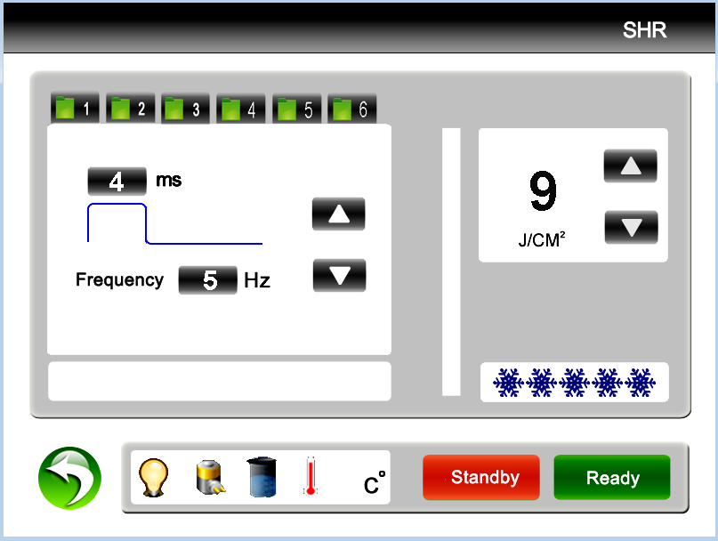
Pulse width
Frequency
Counter
Status notification

Return Key

6 settings memories
Ready /standby
SHR energy adjustment
Contact cooling
Figure two
Click Handle cool levels into full levels (from gray to ) and the sapphire becomes cold in 1 or 2 seconds.
Pulse width: how long a shot work on skin. 1~7ms adjustable
Frequency: how many shots in one second. 1~10Hz adjustable
Energy:
- when the frequency is 1hz/2hz/3hz/4hz, the energy is 1-50J adjustable
- when frequency is 5hz, energy is 1-35J adjustable
- when frequency is 6hz, energy is 1-30J adjustable
- when frequency is 7hz, energy is 1-25J adjustable
- when frequency is 8hz, energy is 1-20J adjustable
- when frequency is 9hz, energy is 1-15J adjustable
- when frequency is 10hz, energy is 1-10J adjustable
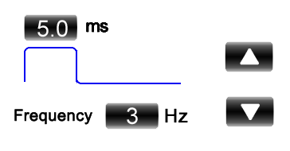
Figure three
When to adjust pulse width or Frequency, you need click the figure into red color:
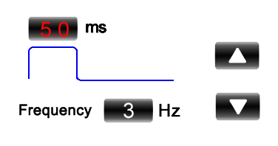
Figure four
Then click  to increase it or to decrease it. Then click the red figure into white color again, or other settings are not able to change.
When you test the machine, you can use pulse width 3ms, frequency 3hz and energy 5J. Then raise the settings slowly according to actual situation.
When settings are ready, press "Ready” button to trigger the treatment head and to charge the capacitances automatically. Press the red button and it shots.
When treatment finishes, press "Standby” button to turn off the head.
Status prompt window 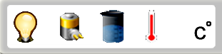

When the machine is Standby, it shows. When click Ready, it shows .
It may change between  and  during fast shots. It is normal.
When the water cycling is bad, the machine alarms and it shows . It may caused by not adding full water or the water circling is wrong, please add full water or shake the machine slightly to make the water circling well.
When water temperature is too high, the machine alarms and it shows . It may caused by too long working continuously. Then you need stop the machine and let it cool.

SHR handpiece

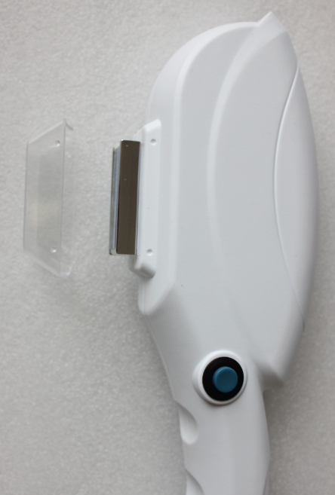

Counter on handpiece: indicate how many shots this handpiece has been used.

5.1.2.2 IPL operation
Press  from SHR below

Press IPL 
Then enter:
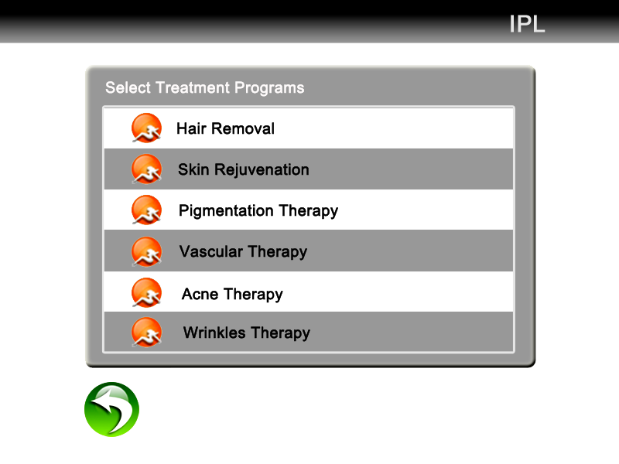
So you can select any function you want. Let’s take Hair Removal for an example. Click Hair removal on the above screen. Here we go:

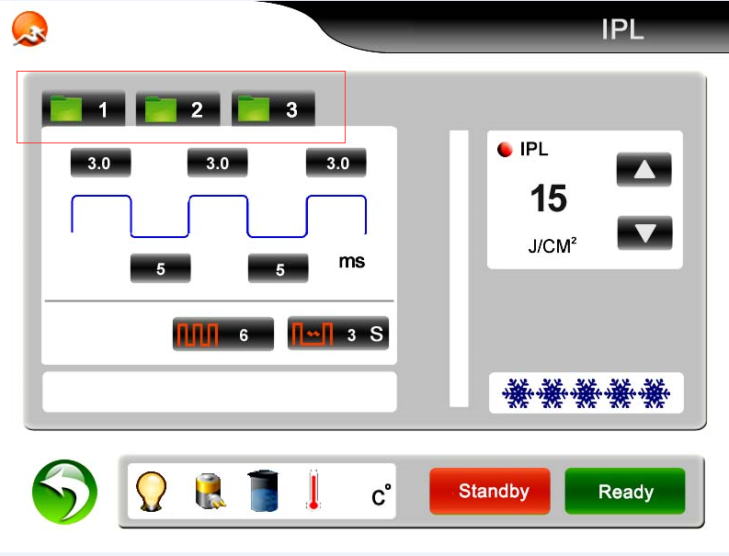
Ready /standby/
Return key
IPLenergy adjustment
Therapy parameter set
Head cooling temperature selection coolingtemperature selection
Status notification
Treatment records

Introduction of the screen:
Settings Storage : to store a group of personalized parameters. 3 files in each application.
Pulse number : it is seepage force. More number, stronger seepage force.
Return: to the screen to select functions
Flash interval ：To adjust the discharge interval, the adjusting extension is 1~5S, you can touch different figure. It the interval time bewteen the two adjacent flashes if keep pressing the switch on the handle.
IPL energy adjustment: to adjust the output energy of the light head. The adjusting extension is from 1 to 50 J/cm2. It can be changed during your treatment through clicking “△or▽”, “△”means up while “▽”means down.
Contact cooling level: to adjust the amount of snowflake from the left to right
The first pulse duration: to adjust the first pulse width, the pulse width is the single pulse which be used, otherwise the first pulse width is the pulse width while many pulses be used. The adjusting extension is from 1 to 10ms by 0.1ms step in.
The first pulse interval: to adjust the stay time between the first pulse and the second pulse, the adjusting extension is from 1 to 100ms by 1ms steps in.
The second pulse duration: to adjust the second pulse width, it will not display when single pulse be used. The adjusting extension is from 1 to 10 ms by 0.1ms step in.
The second pulse interval: to adjust the stay time between the second pulse and the third pulse, it will not display when single pulse be used, the adjusting extension is from 1 to 100ms by 1ms steps in.
The third pulse duration: to adjust the pulse width between the third and the fourth, it will not display when the single pulse be used, the adjusting extension is from 1 to 5ms by 0.1ms step in.
The treatment parameter can be changed, and you can adjust the parameter on the pulse wave pattern. The folder should be clicked again for saving the parameter after you input the needed number. The number will not be changed if the number is too big.

Sketch map of the pulse inputting
The second pulse width
The third pulse width
The first pulse width
The first pulse

The first pulse interval
The second pulse interval

When you finish changing one value on the screen, you must click the value again to confirm it. Then you can go on changing other values.

IPL handpiece
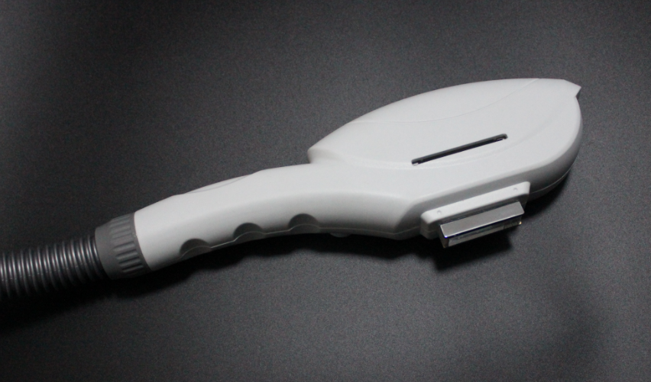

How to use filter for the IPL handpiece:
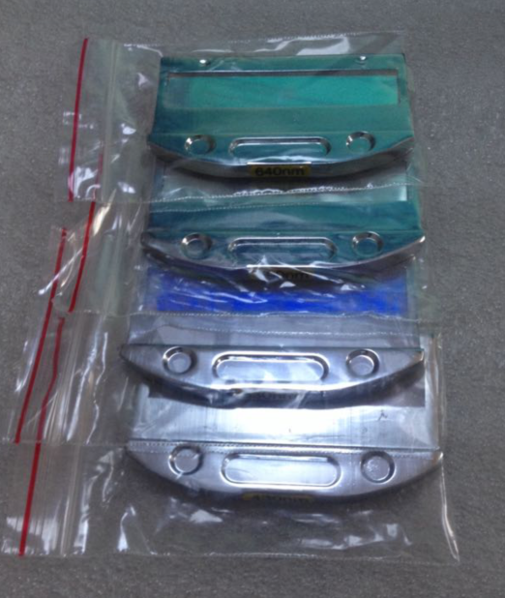

Standard spectra | Application areas
430-1200nm | Acne therapy
530-1200 | Pigment、photo rejuvenation
590-1200nm | Vascular/spider veins
640-1200nm | Hair removal

Choose a right filter and install it onto the handpiece

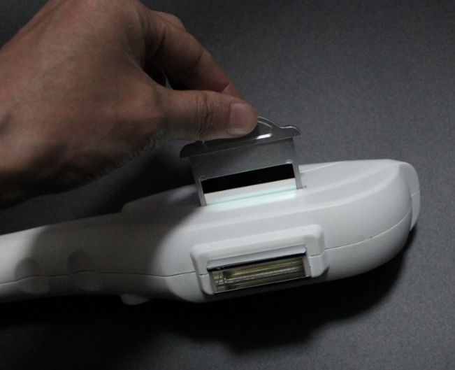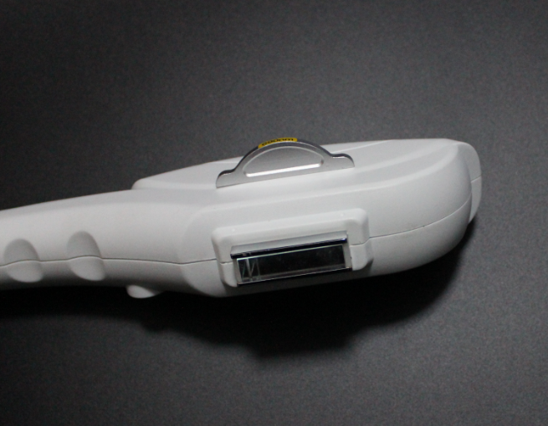
When all the settings are ready, click Ready. You can hear PA. And at the same time the light in the handpiece is on.

Shave the hair
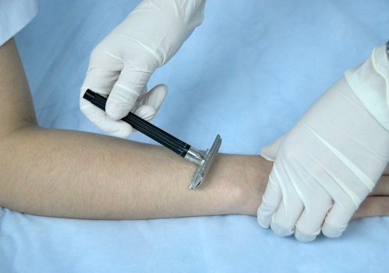

Daub ultrasonic Gel on the skin in 1-2mm thick.
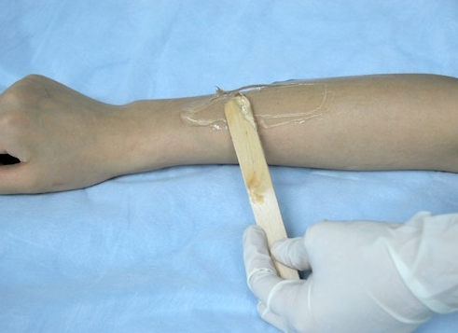

Please pay attention the way of handle during the treatment.

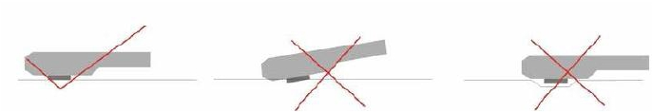
- Smear gel on the skin about 2 to 3 mm thickness before treating.
- Start the machine, processing step by step and adjust the suitable parametre.
- While exerting light pressure, approximate the treatment head perpendicularly over the treatment area. Ensure both metal slices of the head touch the skin naturally at the same time during treatment, If only one side metal slice touch the skin, it can be easily burnt skin. See above picture (1)Then can press the red bottoms to treatment. Before the treatment head leave the skin, please loose the red buttom first then treatment head can be off the skin.
- When the skin is in red after operation, coat the cool gel till the red is die out. Do not wash with water.

- Principles adjusting of parameters.
The white skin and lighter Skin | 1.Increase the power engery
The white skin and lighter Skin | 2.Decrease the pluse delay=(pluse interval) more cooling
The daker skin | 1. Decrease the power energy
The daker skin | 2. Increase the pulse delay ( allow more cooling)
The lighter the hair /pigments | 1.Increase the power engery
The lighter the hair /pigments | 2. Decrease the pluse delay= ( pluse interval)
The darker the hair/ pigment lesion | 1. Decrease the power engery
The darker the hair/ pigment lesion | 2.Increase the pluse delay= (pluse interval) more cooling
Fine Blood Vessels ( vascular lesion) | 1.Increase the power engery
Fine Blood Vessels ( vascular lesion) | 2. Decrease the pluse delay= ( pluse interval)
Thick Blood vessels | 1. Decrease the power engery
Thick Blood vessels | 2. Increase the pluse delay= ( pluse interval)cool more
The smaller the target size / lesion ( vascular) | 1.Decrease pulse delay
The larger the target size/ lesion ( vascular) | 1. Increase pulse delay ( allow more cooling )
Bony prominences (forehead, molar area, shin, bikini) | 1. Decrease the power energy

5.1.2.3 YAG operation
Press from IPL below
Step 1: Press YAG: 

Then enter 6 function interface.
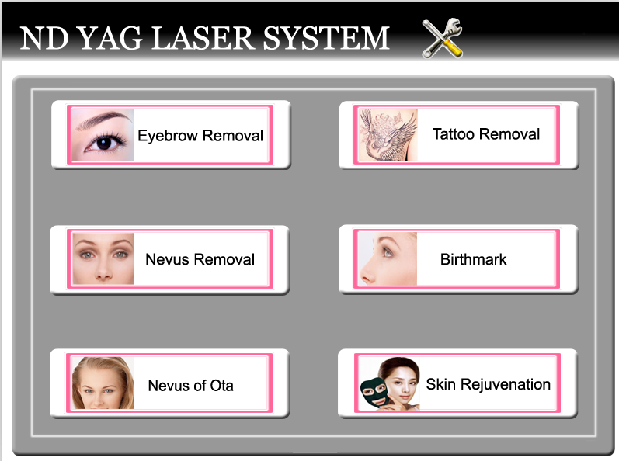

Step 2: Click any function above, e.g, tattoo removal, you enter:
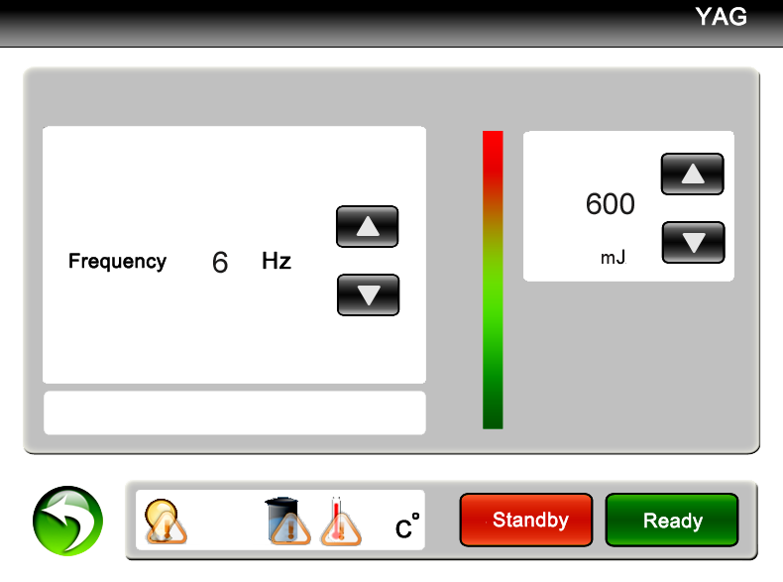
The interface display: status indication; treatment mode and the current treatment mode; the general counter and the current counter; treatment frequency; treatment energy; operating key-press indication.
Step 3: Press the key or the to raise or low the Frequency or Energy.
PLEASE NOTE: Different treatment modes require different frequencies and energy levels accordingly.
Step 4: Press the key and the machine goes into the preparation working state.
You can hear crisped sound as you touch this key, and the indication light turns on. At that time the
aiming beam of the laser lumen is lit and this equipment goes into pre-igniting state, you must pay attention that you make sure that the aiming beam points towards to the ground to protect eyes.


CAUTION: When operation at maximum energy DO NOT set the frequency higher than 5Hz

Step 5: Test and adjust suitable parameters on a non-treatment area
Operators can test between dark magazines or dorsum of hand, at the same time the operator press
the kick pedal with foot and hold the hand piece with your right hand. Aim the treatment tip towards to the testing area to examine the light energy which is emitted, you can see the shining light and hear the sound “ba ba”. The size of testing area is about 1cm² and the paper will turn white, and you can feel a slight tingling sensation .

Step 6: After selecting the correct Mode, Energy and Frequency, aim the laser towards treatment area, press the foot switch and apply treatment accordingly.

To Pause Operation

- First you loosen the kick pedal and press if you need to pause the machine. The other way is press the red “Emergency Switch” directly. The machine will be in safe condition. The laser light will not output if you touch the kick pedal.
- If you need to continue to operate this machine, please press , then you tread the kick pedal and the machine will operate again. Lift the emergency switch if it was pressed.

To Shut Down the Machine

- Remove foot from the kick pedal and remove the hand piece away from the treatment area to stop treating.
- Press the key .
- Place hand piece securely into holder.
- Turn key counter clockwise and remove to prevent unauthorised use.
- Switch off power supply.

Emergency Shut Down

- Press red emergency button
- Turn key anticlockwise and remove

Treatment Shot Counter

During the treatment, the counter can record the shots/flashes during treatment. The counter includes current counter and general counter. The current counter (used to record shots/flashes of unit treatment) can record from 000000—999999. The general counter (used to record total shots/flashes of the machine) can record the number from 00000000—99999999.

The last used parameters in different treatment modes are saved even if you close the power supply. You can change it only when you change it to new parameter.

Temperature Display and Protection

There is error protection function for monitoring the water temperature and circulation.
It will display “ERROR” in the relevant function area, an audible alarm will be emitted and the machine will cease to work. The controlling will exit when you touch any key, and turn to the welcome interface.

Chapter 6 - The Operation of Laser Instrument

Client Consultation
A full consultation and patch test is to be carried out before any treatment takes place.
Consult in private and make client feel comfortable, the consultation will enable you to establish if the client is a suitable candidate for laser therapy.

Consultation Process:

Explain to the client how the Q-Switched Nd: YAG treatment works
The Q-Switched laser delivers specific-wavelengths of light extremely quickly (in nano-seconds) at a very high energy. These pulses are selectively absorbed by the tattoo pigment, shattering it into tiny fragments small enough for the body to recognise the particles as a foreign object, and over the next several weeks some of particles (in shallow cuticle) are discharged from the body and the other part (in deep tissue) are absorbed and digested by the body's macrophages and removed out of the body by the immune system.
Since the specific wavelengths used can only be absorbed by pigment particles, no lasting injury happens to normal skin and normal tissues.
Q-Switch laser systems can now remove all types of tattoo with little or no scarring. Professional and amateur tattoos, as well as traumatic tattoos, resulting from accidents, are treated successfully.
Multiple treatments will be required

Matters that can Influence Laser Treatment
There are many factors which can affect the results of successful treatments and complete removal is not always achievable.
Clients should be given realistic expectations of treatment results, and complete removal of pigment can never be guaranteed.
- Amateur or professional tattoo – Amateur tattoos are easier to remove as usually they are not as deep as professional tattoos and the ink is more sparsely applied. Amateur tattoos are usually only a single colour (black or blue), whereas many professional tattoos are multi-coloured.
- Type of ink used - The pigment divided into plants pigment, mixture pigment, and chemical pigment. The plant based pigment is the easiest to dispel, while the chemical pigment is most difficult. If pigment contains iron and lead in the mixture and chemical pigment, it may not react well to laser treatment and can be difficult to remove.
- Depth of ink - Generally speaking the deeper the pigment, the more difficult to remove. And it also takes many times to dispel. It will easy to dispel if the depth of the pigment is thin. Any treatment will not react well if the pigment is chemical based, even the depth of the pigment is thin.
- Colours in tattoo – Black and blue tattoos are the easiest to remove while the green and yellow pigments are the hardest as there is not an ideal wavelength that either of these colours absorb. Tattoo's that have had white (titanium oxide) applied cannot be removed until the white has faded.
UV inks cannot be treated.
- Age of tattoo - Older tattoos usually easier to treat, new tattoos contain more pigment (ink) and often multiple colours.
- Clients own healing ability - The different physique of people. The factors include age, skin, and body immunity and so on.

Side Effects
A superficial burn wound can be created by the laser tattoo removal treatment, The immediate whitening of the treated area is the inks reaction to the absorption of the lasers light energy creating steam within the surface of your skin which usually last for several minutes.
Clients May Experience;
- Swelling or Bruising
- Pinprick Bleeding
- Feeling of Sunburn
- Blisters,
- Scabs and Crusts
- Pigmentation changes due to loss of skin pigment can occur (temporary except in rare cases).
- Dry Itchy skin
- Temporary hair loss
- Infection

Although times can vary, Complete healing usually takes 4-6 weeks. Some extreme cases can be up to 3 months to heal properly.
Scabbing and blistering routinely occur following treatment and usually occur 8-72 hours after the treatment, which can last 1-2 weeks or longer. When the scabs separates, the skin in the treated area may look pale or pink.

Hemoglobin of the tissue has a strong absorption of the 532nm wavelength. Using the 532 nm wavelength increases the risk of swelling phenomenon, skin surface turning white after vaporization, epidermal necrosis, a certain loss of pigment or pigmentation.
Due to personal immune system difference an increased restoration period between treatments may be required.

Treatment Aftercare
After Laser Tattoo Removal Treatment

- Cold compresses (not ice) and recommended skin care products may be useful to reduce swelling or discomfort.
- You may take over-the-counter pain or anti-inflammatory medication. Hydrocortisone (steroid) cream may decrease any itching or skin irritation. Antibiotic ointment (such as Neosporin) may be used if skin is broken to prevent infection.
- Your skin will be fragile for 2 to 3 days. Use gentle cleansers, but do not rub the skin vigorously and avoid hot water during this time. Skin moisturisers may be used and make-up can be applied if the skin is not broken.
- Avoid sun exposure and tanning creams during the entire course of treatments. Use SPF 30 or greater on the treatment area at all times.
- The treatment area may be left open and uncovered. Do not scrub the area. Do not use any products on the treated area without first consulting our staff.
- Avoid soaking for 24 to 48 hours. No hot tubs, whirlpools or baths, but showers are okay.
- Avoid excessive sweating for 24 to 48 hours. No saunas or vigorous working out.
- Keep areas well moisturised and allow scabs to fall off on their own. This is an expected occurrence with tattoo/pigment removal.
- Avoid irritants such as Retin-A, Retinol, Renova, glycolics, bleaching creams and exfoliants for one week.
- Refrain from alcohol for 3-7 days.
- It is best avoid smoking for a period of several weeks before and after your procedure, as smoking constricts the capillaries and taxes the immune system, thereby slowing healing and results

Medical History

Operator must record details of clients medical history. All patients must complete and sign the history profile prior to treatment. The medical history is reviewed and confirmed with the patient during their consultation.

Contraindications
DO NOT treat anyone with the following conditions unless client obtains a signed letter from his/her doctor confirming that the medical condition(s) will not prevent client having laser treatments;

- Lupus or other autoimmune deficiency
- Pregnant or Breast Feeding
- Bleeding abnormalities
- Treatment of Acne in the last six months
- Kelloid or very thick scarring
- Inflammatory Skin Conditions (e.g: Psoriasis) or Injuries
- Hypo-Pigmentation
- Rheumatoid Arthritis “Gold” Therapy
- Herpes simplex or fever blisters
- Diabetes
- Epilepsy
- Cancer
- HIV/AIDS
- Used St John's Wort in the past 3 months
- Newly Tanned skin (includes; natural suntan, tanning bed, fake tans) in last 30 days
- Waxing/Plucking/Electrolysis/Sugaring within last 6 weeks
- Wearing a Pacemaker, or any Metal Pins/Plates

Note:
This list is not fully comprehensive and others factors may arise during consultation

Photosensitivity Considerations

Many prescription drugs and herbal remedies can cause increased Photosensitivity meaning the skin becomes more sensitive to light.
Photosensitivity reactions are generally either Photo-Toxic or Photo-Allergic. Photo-toxic drugs are more common than photo-allergic drugs. Reactions can include:
- Extreme sunburn
- Swelling
- Stinging and Burning
- Hives
It is important that you obtain a list of common photosensitising medications for reference.

Skin Typing

One of the important parameters for the success of laser treatments is the correct typing of the skin.
Skin type is often categorized according to the Fitzpatrick skin type scale, which ranges from very fair (skin type I) to very dark (skin type VI). The two main factors that influence skin type and the treatment programme devised by physicians are:
- Genetic disposition
- Reaction to sun exposure and tanning habits
Skin type is determined genetically and is one of the many aspects of your overall appearance, which also includes the colour of eyes, hair, etc. The way skin reacts to sun exposure is another important factor in correctly assessing skin types. Recent tanning (sun bathing, artificial tanning or tanning creams) has a major impact on the evaluation of your skin colour. Treat as next darker type if unsure.

Client Consent
All patients must complete and sign client consent to treatment form prior to treatment. The medical history is reviewed and confirmed with the patient during their consultation.

Patch Test
Patch tests should be applied to establish the highest level of energy that the patient’s skin can tolerate without adverse reaction.

- Determine the patient’s skin type and select the settings for the three test spots accordingly.
- Remove any make-up or lotions and cleanly shave the area to be tested. Make sure the area is completely dry.
- Each test spot should be clearly delineated. Increasing energy for each successive spot left to right or bottom to top for consistency in assessment and documentation.
- After 5-10 minutes, record the initial reaction on the test spot notes.
- Test spots on patients with skin types V and VI should be at least 2 weeks prior to treatment in case of late emerging side effects. Other skin types may not have to wait as long.
- Upon return, treat the patient at the highest energy tested that did not cause an adverse reaction (crusting, blistering or pigment change).

Treatment
- We advise you take the second treatment 6 weeks after the first.
- You can shave the eyebrow before removing the eyebrow with device in order to examine the effect.
- Take photos before and after every treatment for reference
- We advise you that you should treat large tattoos and nevus little by little and time by time to avoid to much discomfort to the client. You can also help build client confidence by seeing the contrast between before and after the treatments.
- There maybe the sound of the pigment breaking when you treat the deep tissue of the tattoo because of the strong absorption to laser energy with 1064nm. The tint colour of the pigment can come out the cuticle after absorbing the energy.
- Use a lower energy over bony and thin-skinned areas,
- The results of tattoo removal will be more noticeable in the first few treatments, due to there being more pigment.
- The function of digesting and transportation of the macrophage can continue for a long time, and the colour can fade more during this period.

Chapter 7 - Operation Skill and Technique of YAG laser

Demands before operation

- Before each treatment, the user must check the functional performance of the device in order to avoid any risk of harm to patients or other persons. If the device is used in together with peripheral units, the User’s Manuals for the peripheral units must also be read thoroughly and understood.
- Operators should complete a consultation and build a client file.
- Clean the treatment area, disinfect utensil, and shave the treatment area if necessary. You must pay attention that the area to be treated must be dry, as the treatment will be affected if there is water in the treatment area.
- The operator should wear white clothes and relevant wavelength glasses. Keep the operation room clean and make sure illumination is bright enough.
You should keep the temperature is between 22 and 28°C, and avoid the laser irradiating non treatment area.

The suggested laser parameters during the operation

Treatment Mode | Frequency | Treatment Distance | Energy
Eyebrow removal | 2--3Hz | 1—2cm | 300—400mj
Eye line removal | 1--2Hz | 1—2cm | 300—400mj
Lip line removal | 3—4Hz | 2—3cm | 300—400mj
Tattoo removal | 3--4Hz | 3—5cm | 500—600mj
Spots and naevi removal | 3--4Hz | 3—5cm | 500—600mj
Birthmark removal | 3--4Hz | 3—5cm | 550—700mj

Notice:
- 1064nm gets rid of blue, black and cyan pigment.
- 532nm gets rid of red, coffee and brown pigment.

The light beams should be vertical all the time. All the treatment doses are the parameters referring to the vertical laser beam. If it deviated from the vertical position, the laser flow will be reduced and the laser energy can not be completely utilised.

The light spots should fold and translation to a line when you remove eyebrow, eye line and lip line.

You should remove the spot and naevus gradually in small areas.
The treatment area should ooze blood when you treat the area.

How to Change Treatment Heads of Laser

The laser has two inter-changeable treatment tips, each offering different wavelengths: 1064 nm & 532nm, these screw into the end of the hand piece.

- 1064nm wavelength for black, blue, brown, and other darker colours tattoo removal, this tip is slightly shorter and has a round mirror inside.

- 532nm wavelength for red, orange, pink, and other lighter colours tattoo removal, this tip is longer and has a square mirror.

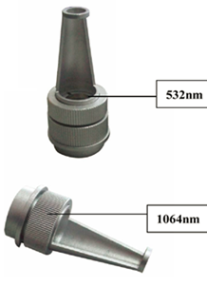

Picture - The Handle of laser and treatment tips.

Directions:
Select the treatment tip according to the treatment of wavelength based on the examples above.
Screw treatment tip in a clockwise direction to attach to hand piece
Screw treatment head counter-clockwise to remove.

NOTICE:
- Please don’t screw the treatment heads too tight.
- Please stop the machine, or enter safe mode when you are changing the treatment heads.

【Quick Tips】
- The result will be better that treating part by part when you treat large area tattoo.
- Please treat with 532nm head first when you treat lighter colour like red. After 2-3 times treatment, the red colour tattoo may possibly turn black or brown. Then treat it with 1064nm head.

Adjusting The Focal Point (Spot Size)

How to adjust energy after you set the power on LCD during treatment

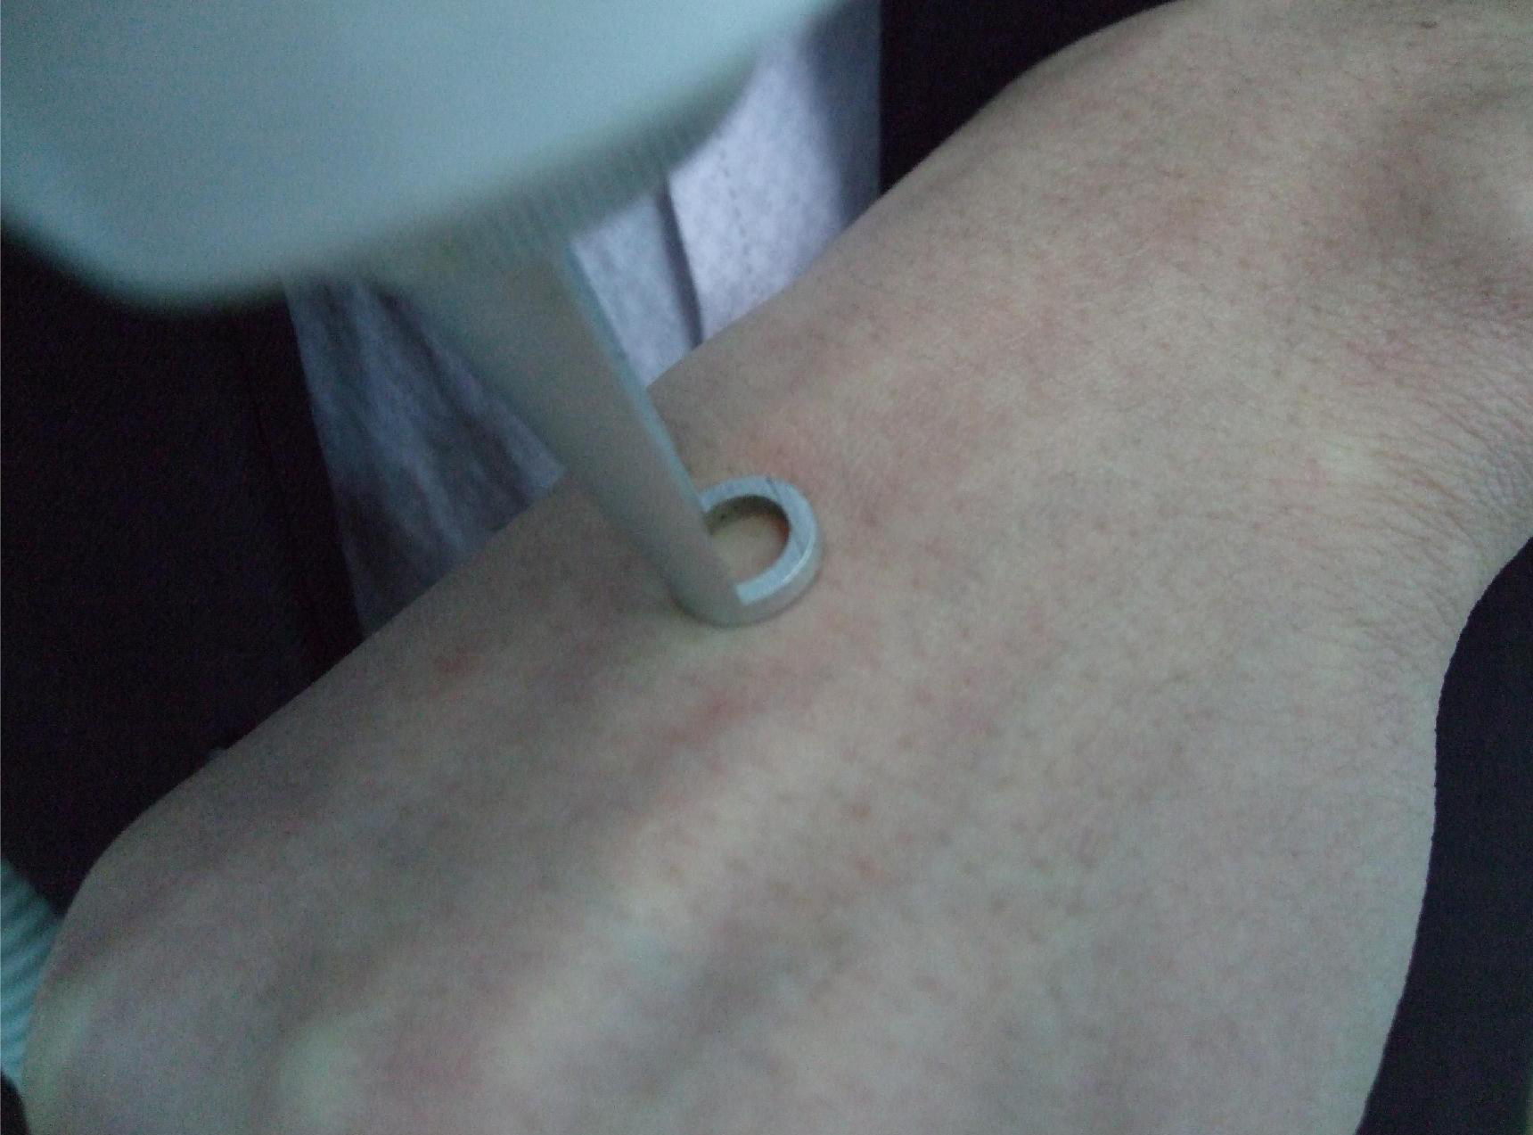  1. Put the head on the skin first | 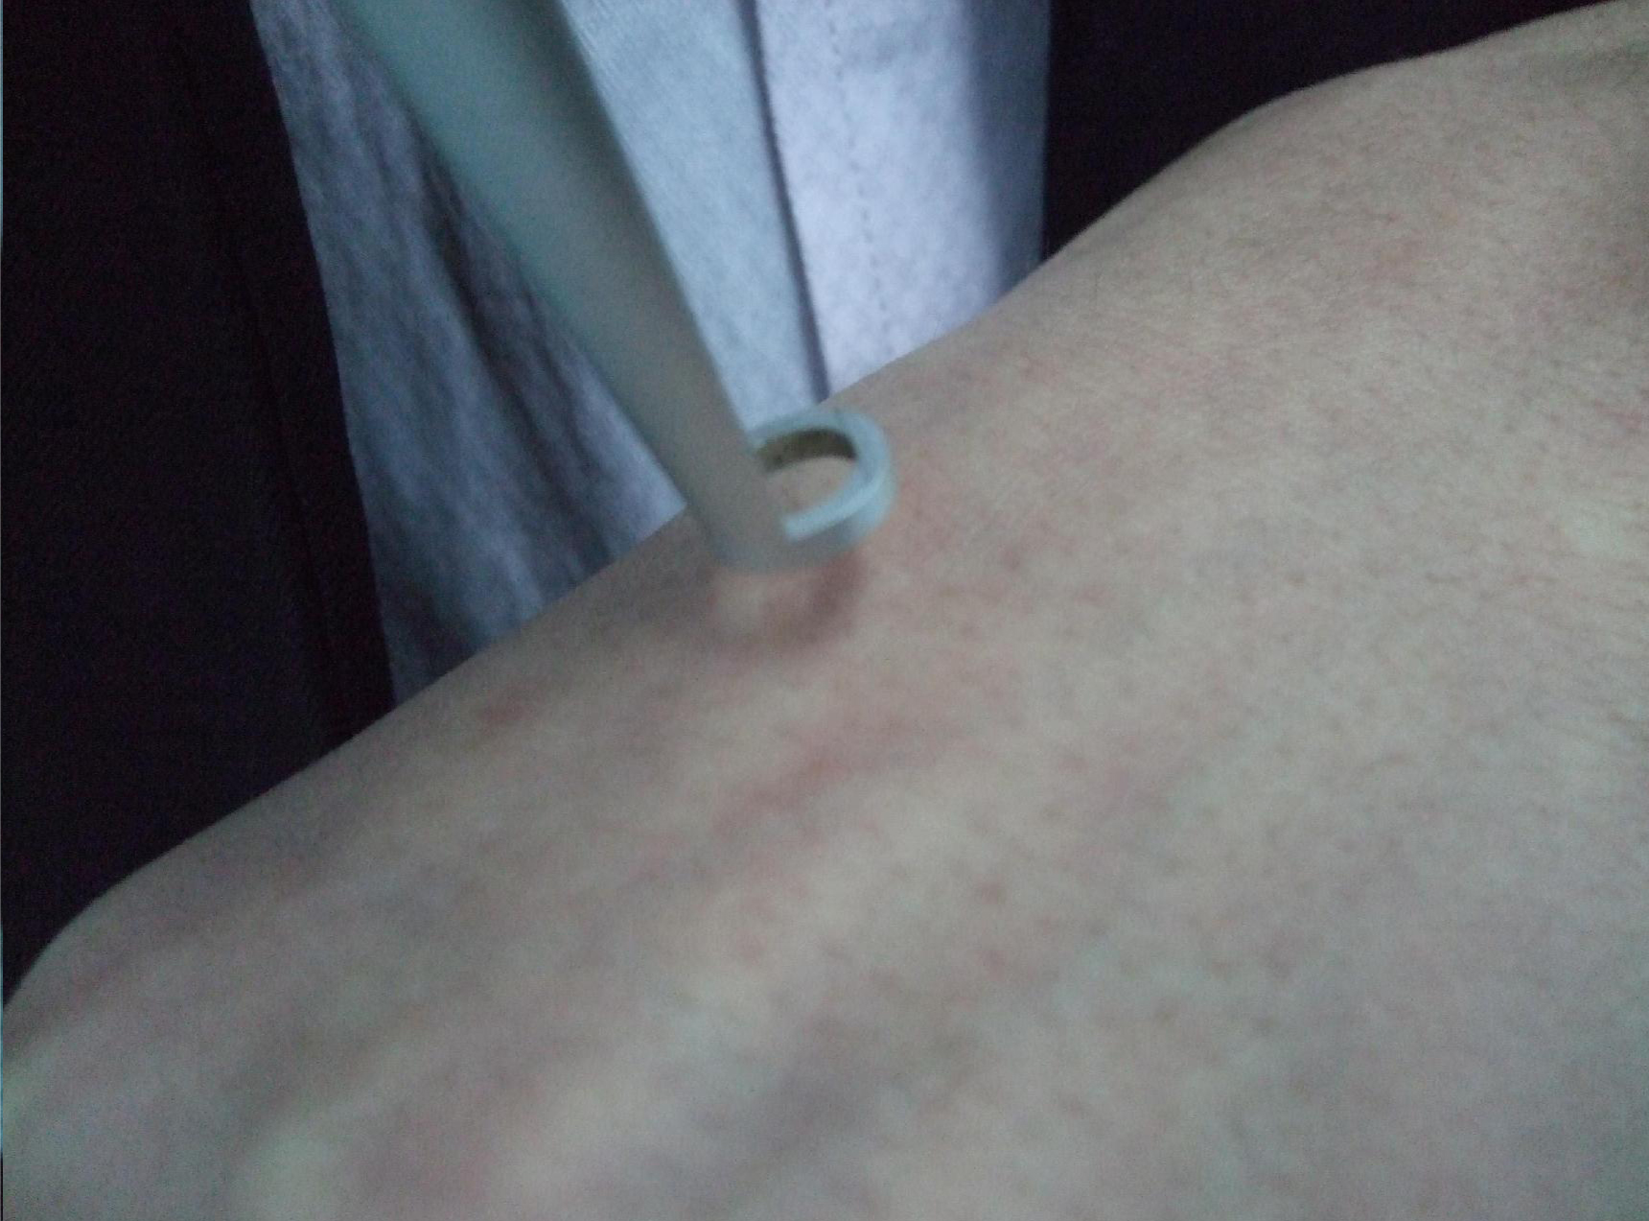  2. Then, prolong the distance between skin and head.
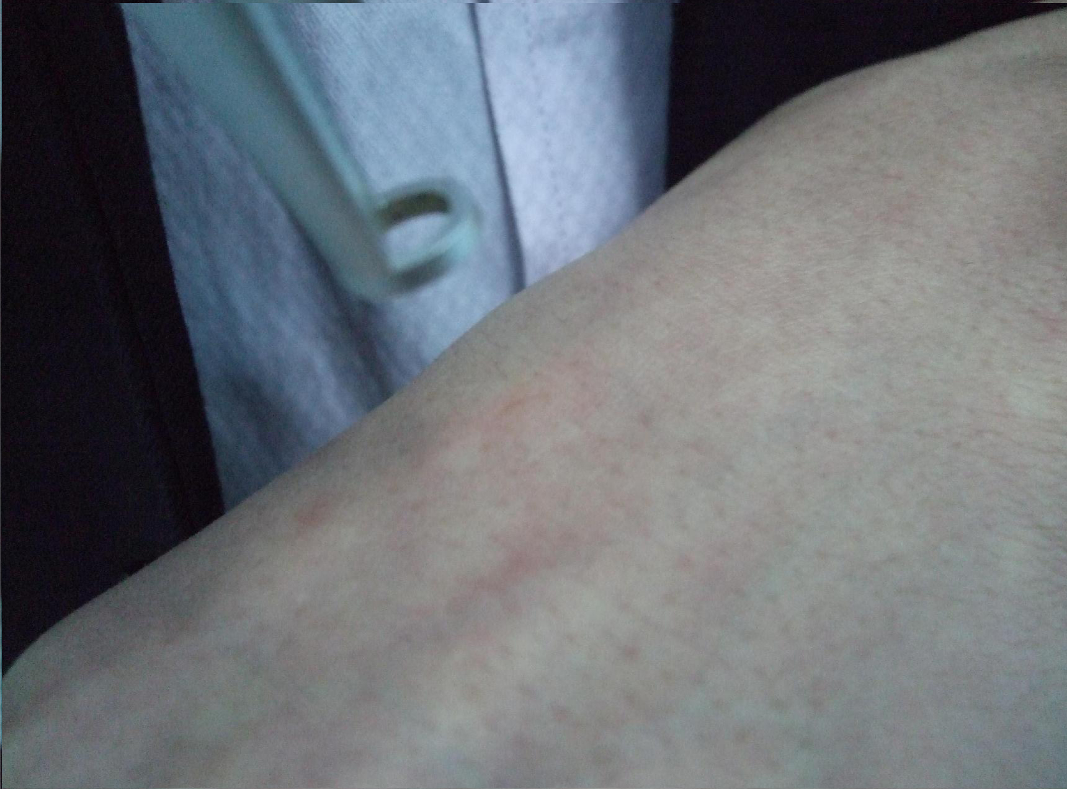  3. The power is most strongest when the laser beam get the focus. | 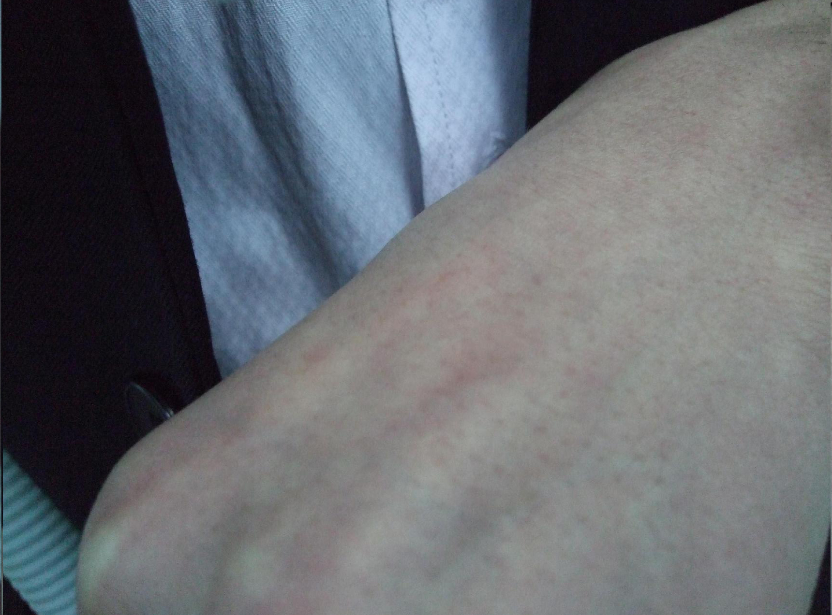  4. Power will be weaker again after the distance between skin and head is longer than the focal point.
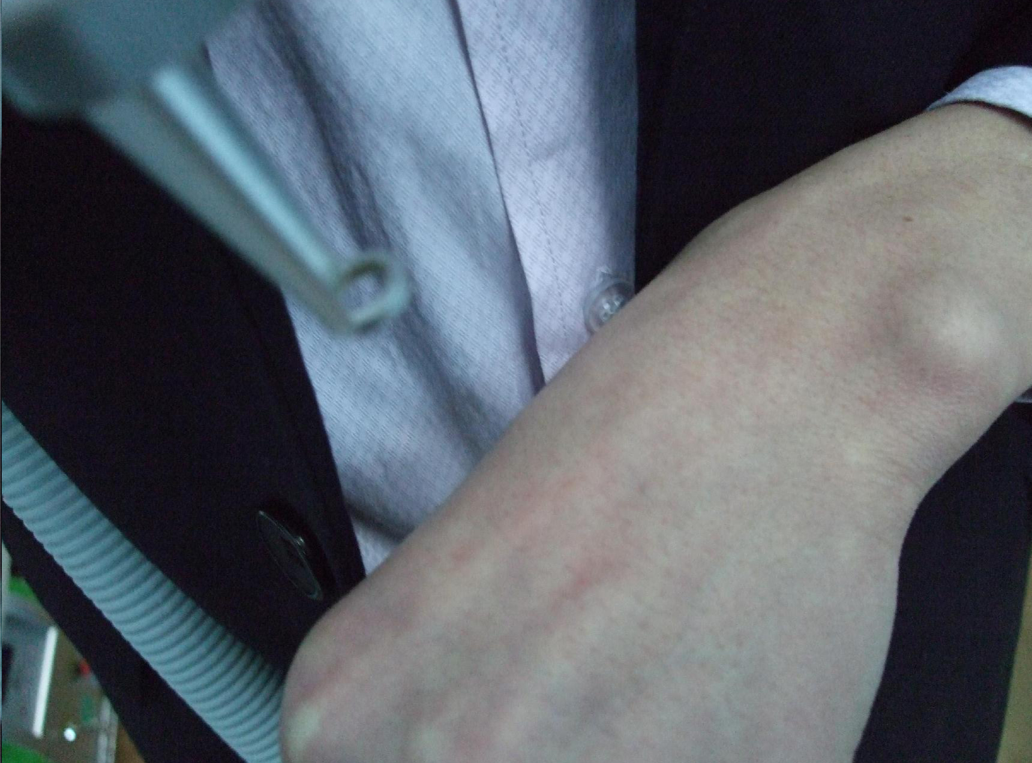  5. Looking for a good distance to control the power during the treatment. | Notice:  Larger Focal Point (spot size) = Lower Power Density  Smaller Focal Point (spot size) = Higher Power Density.

How to control the energy of laser treatment

In the early stage of the use of laser treatment, you can consider the experience of others. The parameters of the treatment of a certain disease are:
Laser energy Q, pulse frequency Y and spot size D (direct).
Energy and Frequency can be adjusted directly through the machines interface and the select button. The spot size can be achieved by adjusting the distance between treatment tip and treatment area.

Energy density =laser energy/Ï*D namely：E=Q/0.787*D

A: In the actual operation, the energy also needs following points to consider:
The skin colour, thickness, rough conditions vary from person to person and due to different sites.
Therefore, the dose is different. When you operate the instrument, the dose should be gradually increased from small to large. You can find a suitable parameter this moment. For instance, first use some spot to experiment, the spot become smaller gradually (that is closing to the scheduling and to lift the treatment head gradually, finally to find the focus position), at the moment energy density (flow) changes from small to large.

B: Please pay more attention to the changes of the skin colour in normal part.
The target pigmentation always exist in corium or deeper in the skin, it should be treated by laser until blood oozing slightly. Another treatment is needed if the pigment cannot be removed thoroughly after 1 treatment.

C: Whether it is skin pigment or vascular skin diseases, we change the energy according to the colour depth. If the colour of the same lesion changes from deep to shallow gradient, the treatment should begin at the darker areas. While moving to the light-coloured, we should raise treatment tip position. This will make the spot size get larger, the energy get lower.

D: If treatment area is large and location is deep, too deep and large area treatment once will lead to local edema, blisters and exudates. So a layered and slicing treatment is suggested.

Operating Technique Introduction for Different Treatments

Eyebrow Removal

a. Removing single blue and black eyebrow:
The light speed can be set to 5Hz; the distance from treatment tip to skin is 1 ~ 2cm. You may treat from the head or may from the tail of the eyebrow. You can take the second treatment if there is colour restoration. The energy can add 20-40mJ and the treatment tip to skin distance can increase up 2-3cm in order to increase the effect
.
b. Shaded eyebrow removal ( the shaded eyebrow can be removed clearly 2 or 3 times)
Set the light speed to 3Hz and the energy can be selected according to the above form.
First you can treat with 1064nm in 2-3cm distance, and then you can treat with 532nm the second time. The brown pigment contains mixed pigment, so it could take more than two treatments; the treatment interval period is from 45 to 90 days. You can choose different light head according to the remaining colour.

Eye Line Removal

The light speed can be set to 5Hz, and the energy should be set to the lowest point. It is about 2-3cm distance from treatment tip to the treatment area, and the light will be seen as reference.
The client’s eyes should be protected with thick medical cloth and eye coverings.
First you remove the client’s lower eye line, and the client should close his/her eyes, at the same time the clients eyeball needs to be looking upwards.
The operator presses the cloth with index finger, and peels away the lower eyelid with middle finger.
When you remove the upper eye line the client should close his/her eyes with eyeball looking downwards. The operator presses the cloth with middle finger and pulls the eyelid with index finger.

Lip line removal

The light speed can be set to 5Hz, and the energy can be selected according to the reference table above. The distance from treatment tip to the treatment area is 3-4cm space.
You can remove the black, coffee and deep red with 1064nm for the first treatment and then use 532nm for the second.
You can use 532nm to remove thin red, red, thin coffee and thin brown. You must pay attention that you carry out the second treatment of removing lip line, soak lip and the lip’s tattoo within 6 months of the first treatment.
The course of treatment is from 45 to 60 days until it is clear.

Tattoo removal

The light speed can be set to 3Hz/5Hz, and you can select the energy according to the reference table above. The distance between treatment tip to treatment area is 3 or 4cm.
The effect will be best if there is blood speckles/pinprick bleeding.
The light head of 1064nm gets rid of blue and black pigment while 532nm gets rid of red and coffee pigment.
The interval between treatments is from 45 to 90 days and course continued until it is clear.

Speckle and naevi removal

The light speed can be set to 3Hz/5Hz, and you can select the energy according to the reference table above. The distance between treatment tip and treatment area is 3 or 4cm. The effect will be best if there is blood speckles/pinprick bleeding.
The light head of 532nm gets rid of red pigmentation while 1064nm gets rid of speckle and naevi.
The course of treatment is from 15 to 30 days until it is clear.

Birthmark and nevus of Ota removal

The light speed can be set to 3Hz/5Hz, and you can select the energy according to the reference table above. The distance between treatment tip to treatment area is 3 or 4cm. The effect will be best if there is blood speckles/pinprick bleeding.
The light head of 532nm gets rid of red pigmentation while 1064nm gets rid of birthmark.
The course of treatment is from 45 to 90 days until it is clear.

Chapter 8 - Detailed Function

There are 6 separate programs of therapy on the screen of TIAN 3. (As below)

Eyebrow Removal
Many women love to embroider their eyebrow with different colour ink. It is very popular in China. The embroider eyebrow can be removed easily after women do not require it any more.

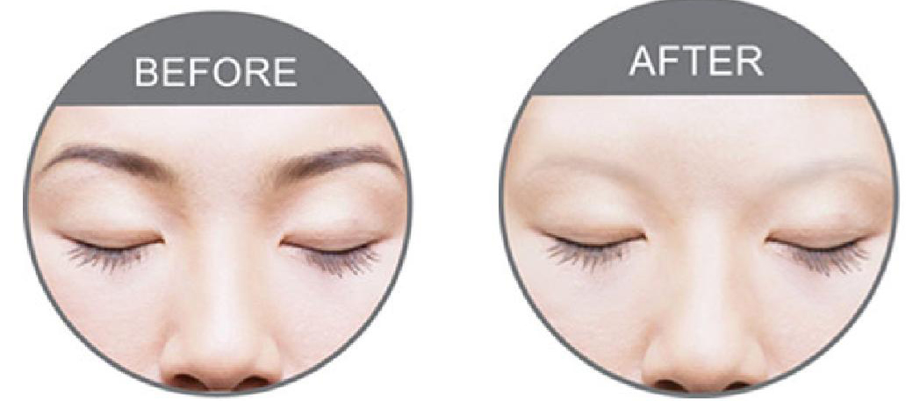

Tattoo Removal
Tattoo removal is the major function. It has two wavelength treatment heads.
1064nm wavelength for black, blue, brown, and other darker colours tattoo removal;
532nm wavelength for red, orange, pink, and other lighter colours tattoo removal.

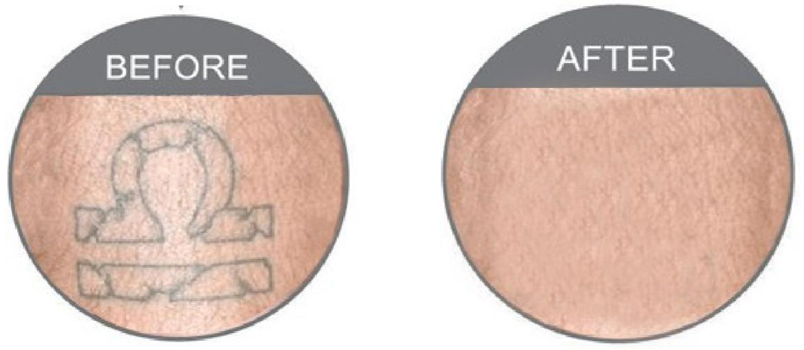
Nevus Removal
It has very good results to remove it if there are several freckles on the face.

Birthmark
Just like Nevus of Ota, birthmark is also very difficult to remove. Because they are
endogenous pigment. The laser can remove it after 3 to 7 times treatment.
But it CAN NOT be treated by laser if the birthmark protrudes the surface of the skin or has hair.

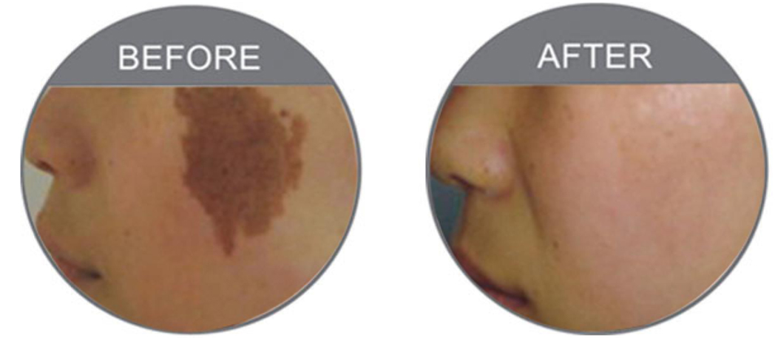

Nevus of Ota
Nevus of Ota is always on the face. It is very difficult to be removed. But THE LASER can do that after approximately 3 to 7 treatments.

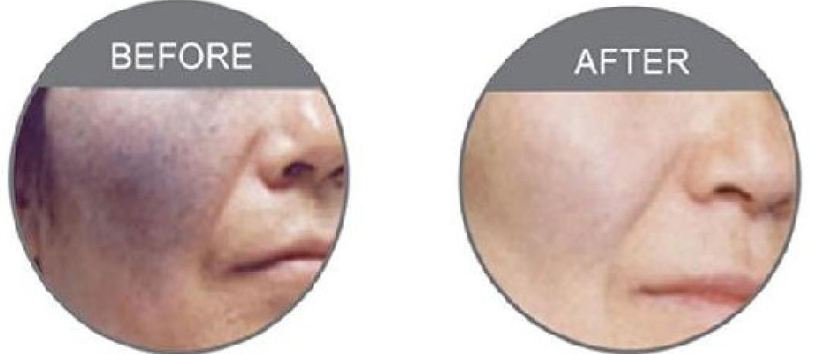

Skin Rejuvenation

THE LASER can do skin rejuvenation and it needs a third laser tip - a black tip and carbon cream.

Further Information;

1. The LASER also has good effect for other pigmentation formed by pathological changes of pigmented skin and mixed colour.
2. The 6 separate programs of therapy can be selected freely. And the parameters (Power,
Frequency) in each application (e.g. Tattoo) can be stored in its own file, which can be
directly used next time. The data in an application does not need re-adjustment. It makes
easy operation and quicker treatment.

Chapter 9 - The knowledge collection of laser removal

- The differences between the first and the second eye brow removal:
You should use the energy which near the focus energy for the first treatment. Distance can be greater than the first time and the energy can be gradually increased during subsequent treatments.
- The reason that the coffee turns to blue and black: -
It is normal reaction if the coffee turns to blue and black because the coffee is a mixture pigment which includes iron, lead ion, iron ion. And all these ion can produces pigmentation, so we advice you remove the pigment with 1064nm for the first time and then use 532nm. You can examine the effect half one month later. You can use 1064nm to remove if the colour turns to blue, and use 532nm if it turns to red.
- Why does some red eyebrow have no reaction after removing?
The pigment does not belong to plant pigment but the chemical pigment, and the iron has reached in to derma layer so it is difficult to remove. You should use the focus energy of 1064nm to break up the pigment until blood spots appear, and then you remove it with 532nm.
- How to remove the speckle of the face?
There are good effects on removing drought spot and butterfly speckle which can be caused by climate. The deep and hereditary speckles are difficult to remove while shallow and formed by acquired factors. You can use the focus energy to remove the senile plaque until blood spots appear. There are three treatment courses with an interval of 45 days between treatments.
- The treatment ways to remove naevi.
Using the focus energy to remove the naevi until blood spots appear.
- Can the scar constitution be removed?
A few people can be removed but the effect is not great. You should not use the focus energy, Use a large spot size and low energy.
- Can the pregnant woman be removed the eyebrow?
Pregnant women are not allowed to accept the laser removal treatment.
- How to remove the red blood streak and what degree will be OK?
We don’t suggest that you remove the red blood streak, because the 532nm can absorb the hemoglobin in the blood. It can form the purpura to cause the operation fail.

Chapter 10 - The Advantages of laser treatment

Laser treatment has many advantages as below for eyebrow and eye line removal, compared to the tradition surgery such as dispelling, frozen, electrocautery, chemical (medicine) +dispelling.

- Less bleeding, the laser beam is very narrow and easy to target only exposure lesions. It doesn’t hurt or injure the surrounding systems: at the same time laser has the effect of “hot welding” to the vessel. It can close the vessel. Therefore it will be less likely to bleed.
- It has less pain. On the one hand because of the thermal coagulation, the nerve ending is damaged and reduces the feeling of pain. On the other hand the treatment area is small and the treatment time is short. Therefore, patients feel less pain. This treatment doesn’t need anesthesia, although some patients may prefer to apply a topical anaesthetic or numbing cream to the skin surface before any treatment.
- The quality of surgery is high. Because there is minimal bleeding during treatment, it leaves a clear view to remove target. Of course it also needs the quality assurance and responsibility of the operator.
- The time of surgery is short. The energy of laser is large and centralized. Completing the point of the treatment only needs a few nanoseconds and a few milliseconds.
- less scar: As following the advanced “the principle of selective absorption” to finish laser beauty, it won’t cause normal tissue irreversible damage, so there is no scar.
- Fewer recrudescences: as the laser treatment to the lesions is complete, the injury to the surrounding normal tissue is minimal. Therefore, the rate of the recrudescence is much smaller than traditional therapy.

Chapter 11 - Maintenance of Laser Instrument

This section describes daily maintenance of the Laser treatment system that can carried out by the customer. Only personnel trained and/or approved by the manufacturer are authorised to maintain the inner workings of this device. Any manipulation to the system may cause damage to the device and will void any warranty.

Ordinary maintenance of the machine

General Cleaning
Clean the outer part of the equipment regularly with soft damp cloth or microfibre cloth. You may also use a neutral detergent, and alcohol free wipes, but do not allow any liquid to seep into the machine.

Clean the output lens

You should clean the lens regularly after use. The spatter of pigment and tissue which splash into the lens in the treatment period may influence the light energy and make the laser become hot. You can loosen off the lens with screwdriver and clean the lens with anhydrous alcohol and a cotton swab. You must keep the gleaming convex surface towards to the inside. Otherwise, it can break if the direction is wrong.

Regular cooling water changes are required

The frequency of water changing depends on usage;

- If you operate the machine on a daily basis, change water every 14 days.
- If you operate the machine once or twice a week, change water after 30 days.

Remove the screw cap from the Discharge Water Hole and drain approximately 2/3 of the water and replace screw.
Remove screw caps from the Overflow Hole and Water Immit Hole; refill the cooling water level as per installation instructions. Allow the water to properly circulate for 5 minutes before preheating.

PLEASE NOTE: The cooling water must be distilled water or pure water, and we advice you use prepared distilled water or pure water which is sold in the market. Mineral water and tap water is not suitable to use, as the impurities in the water will cause a build up of scale which will affect the normal workings of the device and cause irreparable damage which will void any warranty.

Transport, Storage and Moving

- The machine is portable equipment, easy to move.
- Keep and use the original packaging when moving or storing
- Do not shake or drop the device
- If relocating in treatment room, keep device level when carrying.
- Must not hit the light head of treatment, because it has exact optics system.
- Keep water pipe and treatment handle securely packaged by sprung materials.
- Before carrying any long distance, empty cooling water from the water tank.

Troubleshooting Guide

1. The machine will not start
- Check the power supply has electricity and the attaching plugs are securely inserted both ends and socket is switched on
- Check the red emergency button is released.
- Check key is in correct position
- Examine fuse and replace if necessary

2. The water cycle is abnormal when you start the machine
- Check the water level, if there is not enough water inside to cycle properly this will trigger the water level cut-out switch.
- Holding the tube of hand piece, then start the machine to feel water cycle.
- Replace the cooling water inside as per instructions and shake the machine gently to reset the water level switch.

3. There is no laser beam output when you press the pedal.
- Check that the machine is in the correct working state
- Check the pedal, cable and connecting plug for damage, if any part is damaged contact us for a replacement.
- Check the working key is pressed.
- Check energy level output. You can increase the energy through adjust the energy key.

4. The energy becomes weak or there is no light that comes out.
- The machine can not work as effectively if the energy is too low, increase energy level
- The lens is dirty. You should clean the lens as directed.
- The X-light is burnt out; you should change the laser gun.
- You must stop working and not use the machine in 30 minutes if the apparatus has overheated.
- Loosen off the light head and examine if the primary lens is damaged.
- Check the handle and the light head carefully for signs of water leakage. You must change them if there are any leaks.

5. You may get an electric shock when you touch the machine.
- Dry weather and chemical fibre clothes can increase static shocks.
- You should use the three grounding plugs and the electrical outlet must be correctly earthed.
- The voltage is unstable, you should introduce a voltage stabilizer

6. The machine leaks water
- Manipulation handle leaks water.
- Water leaks because of strong shaking or dropping during transportation.
- The water tank and the water pump leak water.
- Please send the equipment to the company at once or counter-claim from the freight company according to the above situation.

7. There is noise in the operating process when you press the preheating key.
- If the device has not been used for a long time, the instrument will simmer slowly. Please turn off and restart the machine.
- Please raise the temperature appropriately if indoor temperature is too low. You can install air conditioning.
- The fans are broken or the fans have friction with other parts. Please change a new fan or clear the fans obstruction.
- The indoor humidity is too high, keep the room dry.
- If the xenon is burnt out, please replace the xenon lamp.

8. Energy weakens gradually during use of instrument
- Any impurities adhered to the treatment tip lens will lead to blocking the light, please check the lens. If there is any pigmentation, dirt or dust etc.; clean as directed.
- Check if the operation hand piece is hot, please let the instrument rest for 30 minutes or replace the cooling water.
- Check the lens. If it is broken, please contact the manufacturer or distributor immediately.

Chapter 12 Taboo Instructions
Taboo
The apparatus cannot be used on people as follows:
    - Pregnant woman, people with hypertension, heart disease or diabetes;
    - People with photoallergy;
    - Not be used on the open wound;
    - People cannot be exposed under intense light;
    - Female in menses;
    - People who are using shall stop using the products getting effect instantly for 1-3 months before the operation by this apparatus.
【Notice】
        - There is dangerous high voltage, please keep all faceplates and cover boards close;
        - The treatment head should be on the pothook when not in use;
        - The treatment head shoots intense pulsed light. Please keep directing it only at operating part;
        - Confirming that all operators and patients who may be exposed under the intense light are taking safety measures (no matter the light shoots from the treatment head or is reflected). All operators shall wear goggle provided by our company;
        - Never look directly at the intense light even wearing goggle.
【Warning】
If an operating part receives superfluous light, it may cause heat injury, and then tissue may be hyperplastic and (or) atrophic and (or) pigments appear on the skin.

Chapter 13 Maintenance Manual
Daily Maintenance
[Notice] Our customers can only take the steps stated in this chapter for maintenance. Only technicians authorized by our company shall make other repairs.
【Caution】
- The apparatus shall be turned off and the power supply shall be cut off. Maintenance with electricity on may injure both of the user and the apparatus;
- Cleaning the surface: The apparatus shall be cleaned every time. Wet soft cloth or mild scour may be used to wipe the surface of the whole apparatus;
- Cleaning the light guiding crystal: Keep the light guiding crystal clean all the time. It shall be cleaned every time after using it. When to clean it, dry it with clean soft cloth firstly; secondly, clean it with soft cloth dipping alcohol. At last, wait for its dryness or wipe it with saline water;
- Water: Water in the system shall be changed once a month. It must be purifying water or distilled water;
- Energy adjustment;
- Steps for changing the treatment head:
  - Turn off the system switch and cut off the electricity cord to avoid damaging the apparatus;
  - Open the small square cover at the backside of the apparatus;
  - Loose coupling of treatment head;
  - Take treatment head out;
  - Tightly connect a new treatment head with the apparatus;
  - Restart the apparatus;
  - The new treatment head can be used;
  - Please contact the engineering department of our company if you have any questions.
Part of its security measures is as follows:
  - Self-inspection system is activated instantly when the apparatus is turned on and the system will monitor the circuit continuously in the operation of the apparatus;
  - Filter / light guiding crystal are used and transmitted onto skin. Impulse light can only shoot from the front of the light guiding crystal;
  - Independent safety circuit can be cut off when the intense light is too strong;
  - Using the red emergency switch to quickly cut off power supply if need;
  - Using the key switch, the apparatus can only be turned on by the appointed person;
  - High-quality molded shell is to prevent electrical leakage caused harm to person.
【Warning】
Any intense light device and harm the people if you operate improper. The equipment can exert high voltage, so people must pay attention when operating the device and take the necessary protection measures.
Sufferer: The safety of the sufferer depends on the high qualified director, and the operating room which decorates properly. The cultural quality of the sufferer is also important, they must know well the treatment principle, and the eyes of them should be protected.
Operator: The operator may contact with high-intension light, and she must wear special safety glasses.
Operating room: You must paste the notice that the high-intension light is working.
【Main Warning】In order to assure the safety of equipment, you must read the warning items following:
- Anyone mustn’t examine this apparatus except the technician who has been authorized by ESC. Attention that dangerous high-voltage inside the machine.
- Make sure that the specified voltage in accordance with the voltage in your own country.
- You can maintain this machine only after you turn off the machine and power-line. It can make personal and equipment damaged.
- The light head should keep clear and prevent the gule from permeating into the light head.
- You must turn off the machine if you find the light head seeping water.
【Warning about Intense Light】
- The intense light can hurt the eyes can cause fire, so you must take the protection measures.
- Radiating excessive light to the cure part of the body can damage the skin and make the usual pigment increase.
- You can’t see the light directly.
- Don’t radiate the light to the skin. You should put the head on the hook hitch.
- The safety of electricity and machinery
    - Keep both panel board and blind flange closed. It’s dangerous if you open the blind flange.
    - There is still the rest electricity even if you disconnect the mains lead, so you can’t take apart the machine except the technician.
    - You can’t open the electricity when maintain the equipment.
    - The equipment weight more than 40 kilograms. You must pay attention when move it. Don’t pull the machine by light head.
    - It is important for the earth wire to touch the ground.
【Prevent fire】
  - The temperature becomes high if object absorb the light, so we must take measure to decrease the number of the inflammable material.
  - Don’t use the inflammable materials, such as ethyl alcohol. If necessary, please use the soap-suds and distilled water.
  - The light head must parch when use it.
【System fire】
  - The equipment has some safety device; all the operators must know the instruction manual.
  - Key switch: The function of the key is to turn on or turn off the current source; all the keys must be provided by our company.
  - Hurry-up switch: The red mushroom switch can turn off the source. It cut down the current whatever condition it should be. Turn it in clockwise direction and the equipment can work again.
Electric shock protection: class one and class BF
Anti-corrosion: common
Don’t use the machine in the environment with flammable anesthetic and the mixture of gas and nitric oxide.
Operation way: continuation

Chapter 14 Knowledge about Skin

1. More Advantages. It can improve various skin flaws:
The treatment mode of IPL has breached the limit of traditional partial focus treatment, which can cure the whole face. The IPL apparatus can also cure the diseases as follows: capillary vessel expanding, erythema, pigment, petty wrinkle, sunburn, brown splash, enlarged pores, whiten skin. The treatment results show that over 75% of skin of 49% of patients has been improved. Facial erythema (75% of patients) and capillary vessel expanding (49% of patients) have been improved. The improving rate of wrinkle of 73% of patients has reached 25%, wherein the improving rate of 36% of patients have reached more than 50% and the improving rate of facial wrinkle and enlarged pores of 76% of patients has reached over 50%. In clinic reflections, skin structure, petty wrinkle, atactic pigment, enlarged pores and capillary vessel expending of all patients are improved.

2. Treatment on the whole face to improve skin’s character in order to resume skin’s flexibility:
New collagenous fibre produces smooth structure: pores become large, petty lines and wrinkles become less and can be reduced to utmost-to make skin more flexible.

3. Excellent results after 14 months and positive appraisal from patients.
Many treatment cases show that the long-time data of treatment with IPL technology is 14-18 months of patients with facial erythema and red face after treatment. The status of 80% of patients is the same as that after their last treatments. Few people get purpura edema. Most people’s convalescence is 1-5 days and two treatments with an interval of 21-45 day leads to better curative effect. There is no report about scars in all of cases. The IPL technology indeed provides safe treatment of nonintervention and non-exfoliation for people with love of beauty and is accepted by general suffers.

4. IPL Skin Rejuvenation is a nontraumatic technology:
Traditional skin rejuvenation technology adopts the grinding way and chemical deep-seated exuviations. Then laser dispelling deep-seated winkles method followed. Although these methods have a certain remedy for some parts of skin aging treatment, patients usually need a rest from work and oppressive pain is accompanied. Potential side effect and shutdown seriously disturbs normal life and work. Photon skin rejuvenation adopts the treatment of nonintervention and non-exfoliation to rejuvenate skin with low-density energy. Accordingly, this technique brings no pain, no side effect, no shutdown and wins higher satisfaction of patients.

5. What is freckle?
It is a kind of small brown or filemot pigmentation on face and is autosomal dominant inheritance, which is serious especially in summer. The development of pathological changes is related to solarization. Freckle occurs mostly to women and emerges in childhood after the age of 6-7 usually. It becomes obvious in youth. Skin lesion due to solarization gets serious in summer but mitigatory in winter. Skin lesion is canary or filemot or brown splash, which is rotundity or elliptical or irregularly shaped. Freckle is concentrated mainly on face, especially from eyes to cheekbones.

6. What is chloasma?
It has another three names, which are butterfly spot, cloasma hepaticum and soot-black macules in physic. It is common and a frequently encountered disease for women. The incidence of the disease becomes more obviously and seriously for the past few years.
In the beginning, chloasmas are in light color. They may be multiple but gradually syncretize into spot in different sizes and shapes with clear borderline. They intersperse symmetrically on exposure parts, usually on cheekbones, forehead and cheeks. They have no subjective symptom.
Chloasma has three types according to their location: it is called superficial type one if it locates on cuticle, shallow-seated type if deep in cuticle and deep-seated type if in corium. This classification is mainly related to treatment. The deeper the location is, the longer the treatment time is and the more difficult the treatment is.
Aetiological agent is very complicated. It may occur to healthy women from youthhood to climacteric. The incidence rate of chloasma caused by oral contraceptive reaches over 80%. Some chronic diseases, especially female diseases of reproductive system, such as menoxenia, adnexitis, acyesis, ovarian cyst and hysteromyoma, may cause chloasma. In addition, chloasma may be caused by other diseases, such as hepatopathy, chronic alcoholism, thyrotoxicosis, tuberculosis and viscera tumor. Many kinds of medicine may cause chloasma. It also can be induced and deepened by sunshine and hereditary factors, sleep disorder, psychic factor and so on are somewhat related to chlosama.

7. What is acne?
Acne is a familiar hair follicle thylacitis in youthhood. It is also called acne vulgaris and commonly referred to as whelk (Qingchundou in Chinese). Acne is usually found on face, sometimes looks like papilla, blain and so on. Sebum is often accompanied and overbrims. The pathogeny has not been clear yet but may be formed synthetically by various factors.
- Androgen-mediated lipid overflow - androgen and its metabolites, such as dual-oxygen copper and sulfuric acid dehydrogenation Cremaster epidermal-steroidal copper increase, which strengthens the activity of sebaceous gland. Secretion of patients with acne skin is higher than that of normal people.
- Funnel of hair follicle keratosis - acne patients’ keratosis of of hair follicle funnel boosts up and its epicyte becomes thick and dense, so it is difficult to drop off. It has not been clear yet why the keratosis of of hair follicle funnel boosts up, but it may be related to free fatty acids in the cortex. In addition, the amount sebum linoleic acid of patients with acne is less than normal, which might be another reason.
- Acne propionibacterium increases- acne propionibacterium belongs to anaerobic organism and is a resident bacterium. Why it increases may be related to funnel of hair follicle keratosis, sebum discharge blocking and relative anoxic environment.
- Inflammation - acne propionibacterium excrete dissolved lipase, which will decompose the triglyceride into glycerol and free fatty acids. Glycerol and free fatty acids further stimulate gland wall keratosis, so the adenovirus mouth is blocked. Experiments prove that carbon atoms containing 8-14 can penetrate hair follicle and goes into corium and then causes more obvious inflammation. In addition, acne propionibacterium can not only produce dissolved lipase but also prolease, hyaluronidase and some chemotactic factor activating complement, which all can bring inflammation of the hair follicle sebaceous gland and papilla, blain, nodules and so on.
- Acne caused by cosmetic – (a) improper cosmetics are used, i.e. people with oily skin use oily cosmetics, making the hair follicle mouth metabolism sluggish. Hair follicles are blocked by hard, dense keratose substance, which leads to expand, these keratose substance forms keratose bolt, plugging in the hair follicle mouth. Accordingly, acne arises. (b) Some cosmetics containing substance of particles, such as a great deal of superfine titanium pigment, whose particles are agglutinated with sebum or stroma. It is easy to plug holes of hair follicle and causes acne. And young people indulge in the cosmetic, making light acnes serious.
Moreover, inheritance may be an important factor causing acne, and orally taking medicine containing iodine, bromine, cortex steroid and so on can make acne more seriously.

8. Six inducements making skin dark and spotted
Specifically, inducement causing skin black and spotted mainly is:
- The arch-criminal-ultraviolet radiation;
- Some sensitive food, such as animal liver and kidney, oyster, shrimp, crab, legume, walnut seed, currant and so on;
- Drinking and smocking;
- Some diseases;
- Some medicine: quina, tranquillizer containing chlorpromazine;
- External cause: rubbing skin hard when having wash.

9. How wrinkle come?
Wrinkle is the result of skin aging. Wrinkle is synthetically formed by internal cause, external cause and other factors.
- Internal cause: in youth, skin is rich of moisture and all kinds of glands’ body fluid are excreted noticeably. Skin is at its best time at this time. Wrinkle is not easy to arise. However, wrinkle will come and temporarily exist if skin is of over hydropenia for reason that skin is not taken good care or diseases arise. If moisture is makeup to skin once, the temporary wrinkle will disappear. But in middle age, the horny layer’s ability of keeping moisture declines. Sebaceous gland is excreted less. Elastic fibers in corium are of denaturation and ruptured. Adipose layer decreases…. All these factors lead to skin’s change. Wrinkle is the symbol of skin aging, which can be seen with our naked eyes.
- External cause: skin is the surface layer, which receipts sunshine, wind, and dryness. These are all factors making more and deep wrinkles. We all know that people living on Qinghai-Tibet Plateau all have deep wrinkles on their faces. This is brought about by wind and sunshine. Ultraviolet radiation in sunshine is one of the reasons for skin aging and wrinkles. Therefore, people should prevent skin from being sunburned. Sunburn prevention and moisture keeping are both important.
In addition, too much make-up is a direct harm to skin. All cosmetics are chemical. Although some cosmetics adopt natural materials, synthetics, such as coloring matters and flavors are also used in their production. Therefore, make-up provides beauty temporarily. It also damages skin and causes wrinkles.
What should attract our attention is that some wrinkles on women’s face are caused by cortex steroids ointment used in external way, such as fludrocortisone ointment, triamcinolone acetonide ointment, compound dexamerhasone acetate ointment. These ointments lead to skin shrinking, thinning and wrinkles.

10. Four-step wrinkle prevention
Wrinkle can be divided into kinetic energy wrinkle and static energy wrinkle. Static energy wrinkle is a kind of wrinkle that can be seen even a person has no facial motion, i.e. part under eyes, at altercates. That is brought from skin aging and from cuticle and corium becoming thin. Kinetic energy wrinkle is a kind of wrinkle that can be seen when a person’s face has a motion, i.e. wrinkles on glabella, sides of eye tail and forehead. But winkles can be also caused if a person’s bodily form is thin with less subcutaneous fat.
According to external changes in different ages, wrinkle’ formation can be divided into four stages: a. Mild aging stage: at the age of about 28-25. Fundamentally no wrinkle can be seen;
b. intermediate aging stage: at the age of about 35-40. Kinetic energy wrinkle arises;
c. relative serious aging stage: at the age of about 50-60. Static energy wrinkle arises;
d. most serious aging staging: at the age of over 60-75. Obvious wrinkles and skin prolapse can be seen.

11. Wrinkle arisen rate of all ages
Wrinkle arisen rate of all ages is recorded in percent form as follows:
At the age of 18-29: wrinkles arise on 44% of women’ forehead
At the age of 30-39: wrinkles arise on 56% of women’s glabellas
At the age of 40-49: wrinkles arise under the eyes of 72% of women and on glabellas of 75% of women
At the age of 50-59: 65% of women have goosefoot lines and 60% have nose-chin veins.

12. How sensitive skin comes?
Is delicate skin easy to form sensitive skin?
No exactly. Sensitive skin is divided into congenital type and postnatal type. The former one is related to inheritance. It is usually sensitive skin. The later one is related to many factors, such as: a. environment, season alternation. Lines are caused by changes of humidity, air pollution and ultraviolet radiation; b. internal disease and incretion disorder, i.e. long-term disorder of stomach and intestines’ function; c. unbalanced nutrition and long-term innutrition; d. spirit, long-term instable spirit, high pressure and excessive blahs; e. medicament, i.e. skin may has dependency on medicine if keeping using punchy or steroids medicine; f. improper maintenance, i.e. skin is cleaned excessively using alkaline products, or excessively remove cutin.

13. How hypersusceptibility comes?
There are four factors that tend to bring and induce hypersusceptibility:
- Food: irritative food, such as seafood, pollen and capsicum and so on;
- Medication: eternal medicine, such as liniment, lintment; medicine, such as aspirin, anodyne, diuretic and so on;
- Cosmetics: alcohol, coloring matter, flavor, antiseptic and sun-screening agent, and hair dye, cold wave lotion and so on；
- Eyewinker: such as animal hair, leather goods, K gold, oil paint and so on.

14. Why sensitivity and hypersusceptibility occur?
Healthy skin has a layer of natural protective membrane-sebum membrane. In normal conditions, it contains about 5%-7% of axunge, 20%-30% of moisture, both of which are in subacidity. It can prevent not only moisture from excessive evaporation, but also ultraviolet and air pollution from hurting skin. Once sebum is damaged, moisture-keeping function will become weak, skins is getting dry, itch, even peels, and becomes weak in guarding against cold and hot and pressure. In this situation, we can see inflammation, red in some parts of skin. That is sensitivity.
Hypersusceptibility refers to that a series of reflection will arise when skin contacts anaphylactogen.

15. Characteristics of hypersusceptibility and sensitivity:
Characteristics of sensitive skin are: a. hair pores are closed and fine. The surface of skin is dry, coarse. Skin is thin, and capillary vessel and asymmetric rubeosis can be seen; b. dryness and itch tend to occur to surrounding of eyes, mouth margin, arthrosis and so on. c. many cosmetics and some medication lead to hypersusceptibility, which is marked by partial rubefaction, itch and anthema if not serious, and swelling, exuviations, many irritable pimples, water seepage and even exuviations in large area and fever heat on the whole body if it is serious.

16. Treatment of hypersusceptibility and sensitivity:
Words from exports:
- For sensitive skin, irritative food and herb cosmetic should not be eaten and used; no contact on hotness, alkali and electricity; do not rub skin excessively; avoid being irradiation by ultraviolet radiation and wash face with cold or warm water.
- Once hypersusceptibility occurs, we should go to find out why. We should keep away from anaphylactogen. Simultaneously, adjusting immunity and improving sensitive constitution through eliminating free radical.
If hypersusceptibility occurs during nursing:
  - Stop using cosmetics. Have a treatment if it is not serious and smear antianaphylaxis medication if it is serious, and stop using the medication at once when the disease straightens up. If it is very serious, go to hospital for a treatment.
  - Nursing order in beauty parlor can be improved. The order is: cleansing cream-skin lotion- cold spraying (B6 vitamin or antianaphylaxis essence can be added)- shiatsu on facial points- antianaphylaxis collagen face mask- cold compress-basic maintaining.

